RTG Visual Studio Automation Framework
_PopVerify Function

Document Control
Process | Name | Title | Date
Authored by | Webber Ling | Team Lead, Quality Assurance | Sep 12, 2015
Approved by

Revision History
Date | Version | Description | Author
Sep 12, 2015 | 1.0 | Initial version | Webber Ling

RTG Visual Studio Automation Framework – PopVerify Function
Table of Contents
Contents
1. INTRODUCTION - 2 -
1.1 RTG VISUAL STUDIO AUTOMATION FRAMEWORK – POPVERIFY FUNCITON - 2 -
2. REFERENCE - 3 -
3. PURPOSE - 3 -
3.1 PURPOSE of RTG VISUAL STUDIO AUTOMATION FRAMEWORK – POPVERIFY FUNCTION - 3 -
4. POPVERIFY FUNCTION DEFINITION AND WORKFLOW - 3 -
4.1 DESCRIPTION - 3 -
4.2 POPVERIFY FUNCTION FOLDER DIRECTORY AND WORKFLOW - 3 -
4.3 POPVERIFY FUNCTION DEFINITION - 4 -
4.3.1 POPVERIFY FUCNTION FOR .NET AUT - 4 -
4.3.2 POPVERIFY FUCNTION FOR WEB AUT - 7 -
4.4 POPVERIFY FUNCTION PARAMETER - 9 -
4.5 POPVERIFY FUNCTION NAMING CONVENTION - 9 -
4.6 POPVERIFY FUNCTION COMMENTS (SAMPLE) - 11 -

RTG Visual Studio Automation Framework
_PopVerify Function

INTRODUCTION

RTG VISUAL STUDIO AUTOMATION FRAMEWORK – POPVERIFY FUNCITON
This document focuses on _PopVerify function, explain in detail, what it is, where it locates, why need it and how it works.
_PopVerify function is NOT a single function. It is a TYPE of function. It is integrated into RTG Visual Studio Automation Framework and takes the key role in this framework.
The _PopVerify function can apply to any type of AUT (Application under Test) and it is closely connected to its corresponding object repository and generic library, for example, for .Net application, its _PopVerify function directly calls the method/function defined in GenericLib_Win.cs, and Web _PopVerify function directly calls the method/function defined in GenericLib_Web.cs, while the objects are predefined in its UI map file.
_PopVerify function has two parts, one is Pop, which used to populate values in the screen, and the other is Verify, which used to verify values of the object in the screen. With these two parts, _PopVerify function can meet most of the QA functional testing requirements.

REFERENCE
<RTG Visual Studio Automation Framework.doc>
<RTG Visual Studio Automation BestPractice.doc> - TBC

PURPOSE

PURPOSE of RTG VISUAL STUDIO AUTOMATION FRAMEWORK – POPVERIFY FUNCTION
The purpose of this document is to introduce the _ PopVerify function which categorized as below:
- _PopVerify Function Definition and Workflow
- _PopVerify Function Naming Convention

POPVERIFY FUNCTION DEFINITION AND WORKFLOW

DESCRIPTION
The _PopVerify function definition and workflow describes its function definition and the internal function call flow and its related UI Map as well.

POPVERIFY FUNCTION FOLDER DIRECTORY AND WORKFLOW
_PopVerify functions are screen/page specific functions which apply to its screen/page only, which means they are defined and stored in <ScreenName>.cs file and its corresponding objects defined and stored in <ScreenName>.uitest file.
_PopVerify functions call the methods/functions (e.g. _SetSyncUDWeb) defined in its corresponding (.Win or Web, etc) function library, which will be called in test scripts. The <ScreenName>.uitest file stores all screen/page related objects and is used in _PopVerify function.
And, ideally, the test script is a combination of _PopVerify functions. Refer to below work flow.

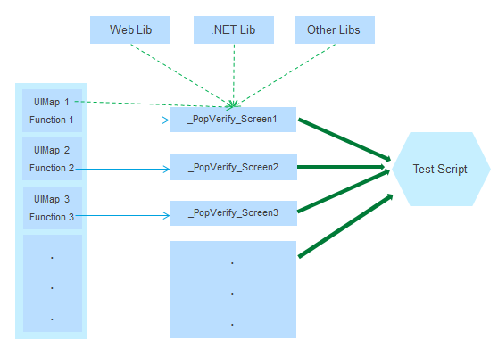

POPVERIFY FUNCTION DEFINITION
_PopVerify function is a type of function that defined in each <ScreenName>.cs file. It is a screen-based function which means each screen in the AUT has its corresponding _PopVerify function with all objects input values as input parameter, which can be used to populate into the screen object or verify. (In some situations, there maybe lots of objects in one screen, so we can split the _PopVerify function for this screen into several _PopVerify functions using proper naming convention.)

POPVERIFY FUCNTION FOR .NET AUT
This is an example of .Net AUT (Retirement Studio) _PopVerify function.
In .Net application “Retirement Studio”, there is a dialog box named “Client”, refer to below screenshot.

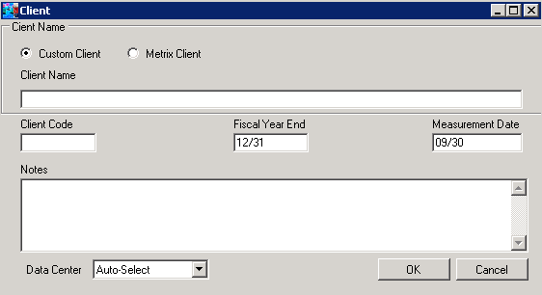
There are ten objects in this dialog, two RadioButton, four Edit, one ComboBox and two Button, which means there should be ten objects as input parameter for this _PopVerify function. Refer to below screenshot.
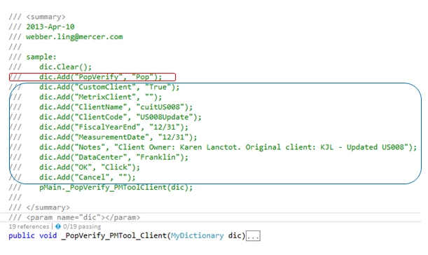
Except above ten parameters which depend on screen objects (in blue rectangle), there is an additional parameters (in red rectangle) which is a general parameter for every _PopVerify function.
General Parameter in _PopVerify Function
- PopVerify – It indicates which operation the function will carry out, “Pop” to populate the value into screen objects or “Verify” to verify screen object values. Only “Pop” or “Verify” is valid input for this parameter.
_PopVerify Function Code Implementation for .Net AUT
All _PopVerify functions’ code implementation follows the same standard and the function looks like as below:
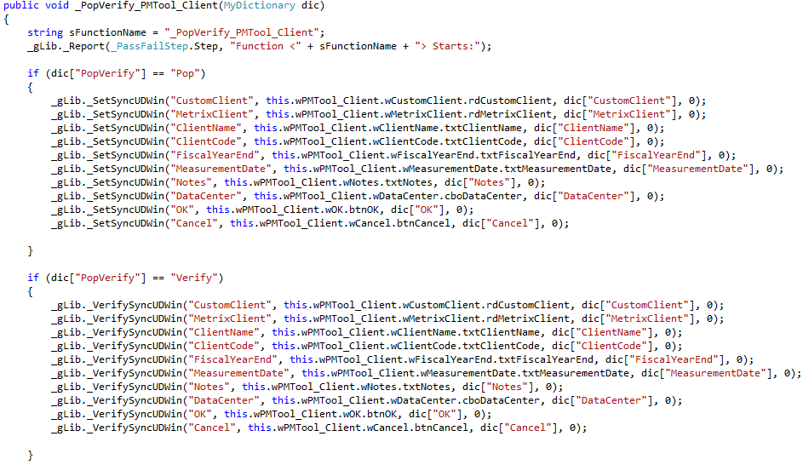
- Parameter Pass – Get the input parameter value using Dictionary
sFunctionName: equals the function name (includes the screen name) which will be used in step report code to generate user friendly results
PopVerify: indicates which part of codes to go into, “Pop” or “Verify”

- Populate Code Implementation – Codes for Populate
This part is used to do the populate functionality if _PopVerify is set to “Pop”. All standard .Net objects use the same customized method _SetSyncUDWin which are defined in GenericLib_Win.cs.
The _SetSyncUDWin method is defined to set value to any type of standard .Net objects, e.g. if dic[“ClientName”] = “TestingClientName” for Edit(“ClientName”) and then the method will set string “TestingClientName” to this object, if dic[“DataCenter”] = “Franklin” for ComboBox(“DataCenter”) and then the method will select drop down item “Franklin” in this combo box.
The first parameter for _SetSyncUDWin method is the description of the object that the code to interact with, which will logged into the testing log file for debugging or further reference. They are used to be as same as control name e.g. OK button’s description equals to “OK”.
The second parameter for _SetSyncUDWin is the object defined in corresponding UI map.
The third parameter is the actual value to set to this object, e.g. dic[“OK”] equals “Click”, will set click on Button(“OK”).
The last parameter is object sync time, the method will use user input value, e.g. 10 means code will wait up to 10 seconds before the object is ready to accept input. If it is not ready within specified time, codes will popup warning message box. And it will use default time out setting in Config.cs if user codes the default value 0 like above sample codes.
- Verify Code Implementation – Codes for Verification

This part is used to do the Verify functionality if PopVerify is set to “Verify”. All standard .Net objects use the same customized method _VerifySyncUDWin which is defined in GenericLib_Win.cs.
The _VerifySyncUDWin method is defined to verify any type of standard .Net object by comparing the pass-in value and its runtime value. For example, if dic[“DataCenter”] = “Franklin” and then the method will get object current selection to compare with “Franklin” and will report PASS if it matches, FAIL if it does not match.

POPVERIFY FUCNTION FOR WEB AUT
This is an example of Web application (Mercer Globe) _PopVerify function.
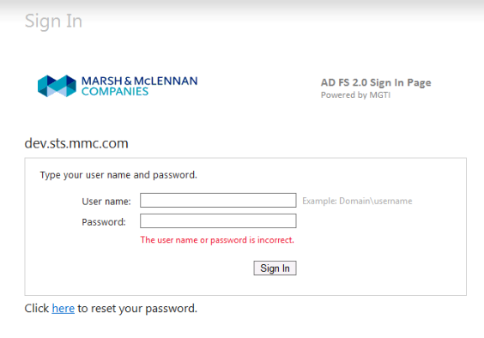
On Mercer Globe login page, it contains very typical objects, which includes user name, password, sign in, example and warning text (if user set incorrect info). Also, there are other objects, for example, mercer logo, hint text, reset password text, etc.
Ideally, for _PopVerify function, we may cover every object in the screen, but for the functionality testing point of view, cut down the unnecessary objects/codes makes easy maintenance of object repository is also an option.
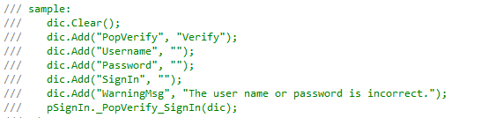

_PopVerify Function Code Implementation for Web AUT
All _PopVerify functions’ code implementation follows the same standard and the function should looks like below. It is very similar with the .Net PopVerify function because they follow the same rule.
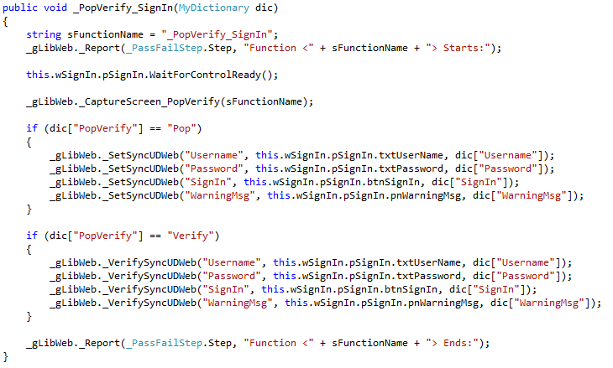
- Parameter Pass – Get the input parameter value using Dictionary object
sFunctionName: equals the function name which will be used in step report code to give out user friendly results, also the screen name is included here.
PopVerify: indicates which part of codes to go into, “Pop” or “Verify”

- Populate Code Implementation – Codes for Pop part
This part is used to do the populate functionality if dic[“PopVerify”] is set to “Pop”. All standard Web objects use the same customized method _SetSyncUDWeb which are defined in GenericLib_Web.cs.
The _SetSyncUDWeb method is defined to set value to any type of standard Web objects, e.g. if dic[“Password”] = “password01” for Edit(“Password”) and then the method will set string “password01” to this object, if dic[“SignIn”] = “Click” for Button(“SignIn”) and then the method will click on button “SignIn”.
The first parameter for _SetSyncUDWeb method is the description of the object, e.g. “Username”, which will be logged in testing log file for debugging or further reference.
The second parameter is the object to take the input. For example, txtUserName.
The third parameter is the value to be set to this object, e.g. “User1” for dic[“Username”].
Note:
There is no fourth parameter here as _SetSyncUDWin. This is because there are multiple overrides of _SetSyncUDWeb (same as _SetSyncUDWin), code uses default timeout setting if it only takes 3 parameters. User can refer to GenericLib_Web.cs to find more detailed info.

- Verify Code Implementation – Codes for Verify part
This part is used to do the Verify functionality if dic[“PopVerify”] is set to “Verify”. All standard Web objects use the same customized method _VerifySyncUDWeb which is defined in GenericLib_Web.cs.
The _VerifySyncUDWeb method is defined to verify any type of standard Web object by comparing the pass-in value and its runtime value. For example, if dic[“WarningMsg”] = “The user name or password is incorrect.” and then the method will get object runtime displayed text to compare with assigned value and will report PASS if it matches, FAIL if it does not match.

POPVERIFY FUNCTION PARAMETER
All _PopVerify functions use the same format of parameter passing dic, which is a Dictionary object. It supports multiple fields definition and able to use parameter name to index its value. Meanwhile, runtime size expanding is supported to make easy, dynamic maintenance of function parameters.
Based on this feature, the _PopVerify function uses Dictionary as standard input parameter.

POPVERIFY FUNCTION NAMING CONVENTION
RTG Visual Studio Automation Framework is a function driven (_PopVerify) framework, which means its test scripts are a combination of various screen-based _PopVerify functions. It is very important for the function creator to follows standard naming convention. Function user will frequently look up the function library and pickup expected function based on function/screen name.
Well-defined function name will help function user to locate function in the library in an efficient way.
For example, for standalone application (Retirement Studio), there is a dialog box whose parent is Retirement Studio Home screen and then we shall name the PopVerify function as “_PopVerify_HOME_ServiceProperties”.
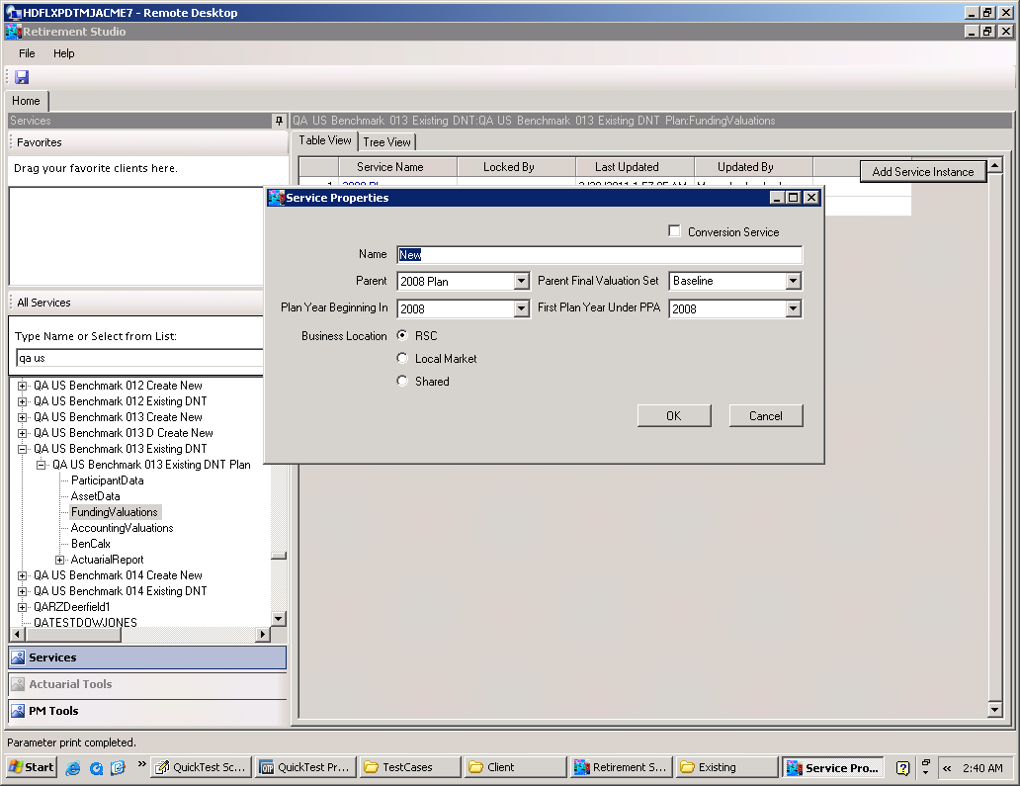
The format of the name of PopVerify function is:
_PopVerify_<Parent>_<ScreenName>
- _PopVerify: This is the prefix for all _PopVerify functions.
- <Parent>: This is the parent screen of the current screen, in this example, “HOME” is its parent screen. This is optional.
- <ScreenName>: This is the screen which the _PopVerify function focuses on, it should use the exact display screen name without space, special characters.

For Web application, it is recommended to use the displayed Page name, e.g. in Mercer Globe, there is a login page:
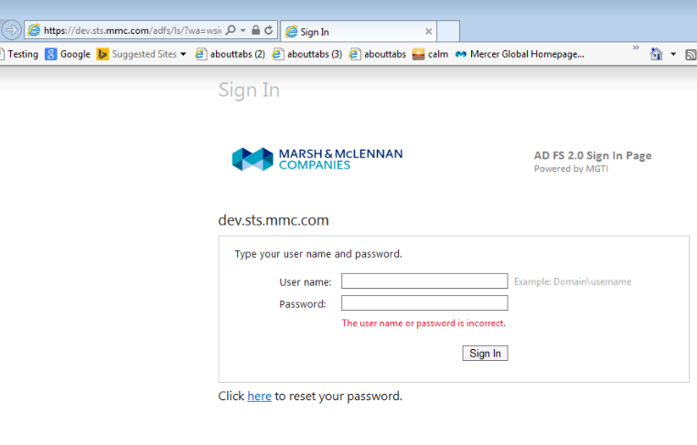
In this case, “_PopVerify_SignIn” is a recommended name for this _PopVerify function.

POPVERIFY FUNCTION COMMENTS (SAMPLE)
All _PopVerify functions should have comments and sample codes with all necessary parameters included as below.
This is because function user can easily copy/paste/update the sample codes to generate they own function calls, which make scripting much easier.

Below codes from MDDS login page _PopVerify function:
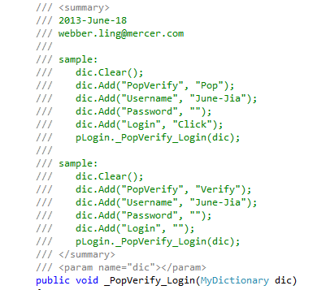

Below codes from Retirement Studio PM tool client screen _PopVerify function:
